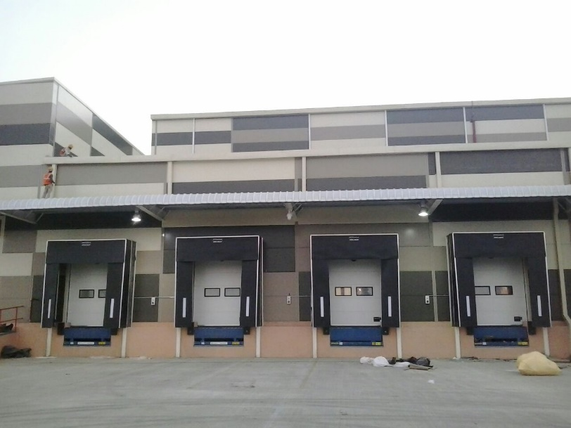

Sr. No | Specification | NIHVA Assaabloy Rectractable Dock Shelter
1 | Door type | Dock Shelter DS6060A
2 | Curtain colour | Black
3 | Parking Guides | White, Yellow
4 | Wall Fixings | Concrete, Sandwich light Concrete, Load house cavity, insulated panel
5 | Top & Side Curtaiins | Double Layer High Quality Polyester
6 | Thickness | 3.0 mm
7 | Weight | Approx 3400 g/m2
8 | Continous Roof Cover | One layer high quality Polyester
9 | Thickness | 0.5 mm
10 | Weight | Approx 680 g/m2

